|  |
| --- |
| 23CS2033-OBJECT ORIENTED PROGRAMMING LAB-2025 Reg.no: URK24CS7137 |

|  |  |
| --- | --- |
| Ex No.2 | BASIC JAVA PROGRAMS |
| Date: | 29.7.25 |

**1.Write java program to Reverse a string.**

**Aim:** To write a Java program that reverses a given string.

**Description:**

The program defines a class Reverse inside the package rl. It contains a main method that reverses a given string and prints the result.

1. A string str is initialized with the value "meow".
2. An empty string rev is created to store the reversed result.
3. A for loop runs from the last character of str to the first (str.length()-1 to 0), appending each character to rev.
4. After the loop completes, rev contains the reversed string "woem".
5. Finally, the program prints the message:

this is the reversed string:woem

**Algorithm:**

Step 1. Start

Step 2. Initialize a string variable str with a value (eg. "meow").

Step 3. Create an empty string variable rev.

Step 4 :For loop:

1. Start from the last character index str.length() -1.
2. Repeat until the index reaches 0..
3. For each character, append it to rev.

Step 5. After the loop ends, rev will contain the reversed string.

Step 6. Print the reversed string

Step 7. Stop

**Program:**

public class reversestring {

public static void main(String[] args) {

String str="meow";

String rev="";

|  |
| --- |
| 23CS2033-OBJECT ORIENTED PROGRAMMING LAB-2025 Reg.no: URK24CS7137 |

for(int i=str.length()-1;

i>=0;i--) {

rev=rev+str.charAt(i);

}

System.*out*.println("this is the reversed string:"+rev);

}

}

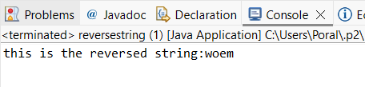**Output Screenshot:**

**2.Write a program to print sum of elements in an array.**

**Aim**: To write a Java program to print the sum of elements in an array.

**Description:**

The program defines a class input inside the package rl. It calculates the sum of all elements in an integer array and displays the result.

1. An integer array num is initialized with the values {1, 2, 3, 4}.
2. A variable sum is declared and initialized to 0 to store the total sum.
3. A for loop runs through each element of the array using the index i from 0 to num.length-1.
4. Inside the loop, each element num[i] is added to sum.
5. After the loop finishes, the program prints:

sum of array of elements:10

**Algorithm:**

Step 1. Start

Step 2. Initialize an integer array num with values {1, 2, 3, 4}.

Step 3. Create an integer variable sum and set it to 0.

Step 4. For loop:

1. Start from index 0 to num.length -1
2. For each element, add num[i] to sum

Step 5. After the loop, sum will contain the total of all elements in the array.

Step 6. Print the value of sum.

Step 7:Stop.

|  |
| --- |
| 23CS2033-OBJECT ORIENTED PROGRAMMING LAB-2025 Reg.no: URK24CS7137 |

**Program:**

public class sum {

public static void main(String[] args) {

int[]num= {1,2,3,4};

int sum=0;

for (int i=0;i<num.length;i++) {

sum=sum+num[i];

}

System.*out*.print("sum of array of elements:"+sum);

}

}

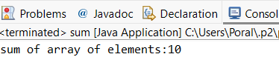**Output Screenshot:**

**3.Write a java program to check whether a given string is a palindrome or not.**

**Aim:** To write a Java program to check whether a given string is a palindrome or not.

**Description:**

1. Initialize variables:
   * A string str is created with the value "madam".
   * An empty string rev is initialized to store the reversed string.
2. Reverse the string:
   * A for loop runs from the last character (str.length()-1) to the first character (0).
   * Each character is appended to rev to build the reversed string.
3. Print the original string:
   * The program prints "String: madam" to display the original value.
4. Check for palindrome:
   * The original string str is compared with the reversed string rev using .equals().
5. Display the result:

|  |
| --- |
| 23CS2033-OBJECT ORIENTED PROGRAMMING LAB-2025 Reg.no:URK24CS7137 |

* + If both strings are equal, it prints "is a palindrome"; otherwise, it prints "is not a palindrome".

**Algorithm:**

Step 1:Start

Step 2:Initialize a string str with a value (e.g., "madam").

Step 3:Create an empty string rev to store the reversed version of str.

Step 4:Loop through the original string in reverse order:

1. For i from str.length() - 1 down to 0:
2. Append str.charAt(i) to rev.

Step 5:Print the original string.

Step 6:Compare str and rev using .equals():

1. If they are equal, print "is a palindrome".
2. Else, print "is not a palindrome".

Step 7:Stop

**Program:**

package EXP2;

public class palindrome {

public static void main(String[] args) {

String str="madam";

String rev="";

for(int i=str.length()-1;i>=0;i--) {

rev=rev+str.charAt(i);

}

System.*out*.println("String: "+str);

if(str.equals(rev)) {

System.*out*.println("is a palindrome");

}

else {

System.*out*.println("is not a palindrome");

}

}

}

**Output Screenshot:**

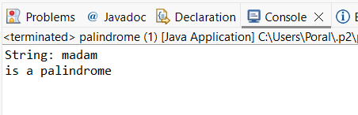

**Result** The Java program executed successfully, and produced the expected output without any errors**.**